Lab 2 Pseudocode

4.9 ASCII Code of a Character

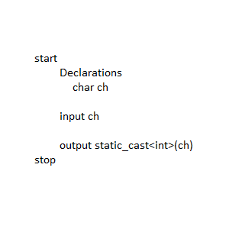

4.15 Phone Key Pads

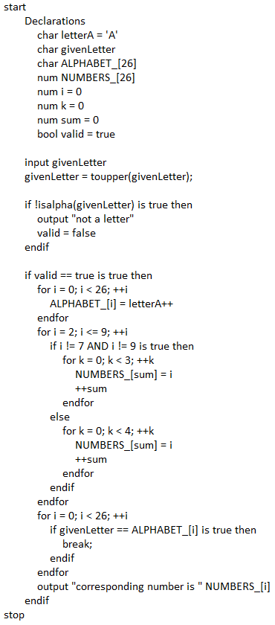

4.19 Order of Three Cities

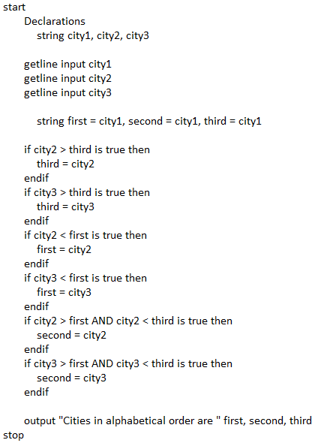

4.23 Check Social Security Number

